# LWSC 3007 Week 9 & 10: Land use change scenarios using SWAT

|  |
| --- |
| **Note that there 4 assessments for the practical components (see the Unit outline), which contribute 5, 15, 15 and 15% of your final mark. These assessments are in week 3, week 5, week 9 and week 13. The assessment tasks will be posted on Blackboard at the beginning of each period.** |

# Aims of this practical:

* Understand three different ways of implementing land use into SWAT
* Apply these methods to a calibrated model for Cotter and Goodradigbee
* Assess the impact of landuse change on streamflow, evaporation and streamflow components using R analysis of the output from the SWAT scenarios

# Introduction

As highlighted in the lecture, landuse change is continuing and on-going and introduces non-stationarity in catchment hydrology. The question is how we might simulate this using the SWAT model to make the model adapt to changes in landuse, or to study landuse scenarios. In the lecture we reviewed some of the research in this area.

In SWAT there a few different ways to tackle this problem, and each of the approaches has its own limitations. We will guide you through a few of the different approaches and look at how this predicts changes in the water balance of the catchment.

Using my SWAT output:

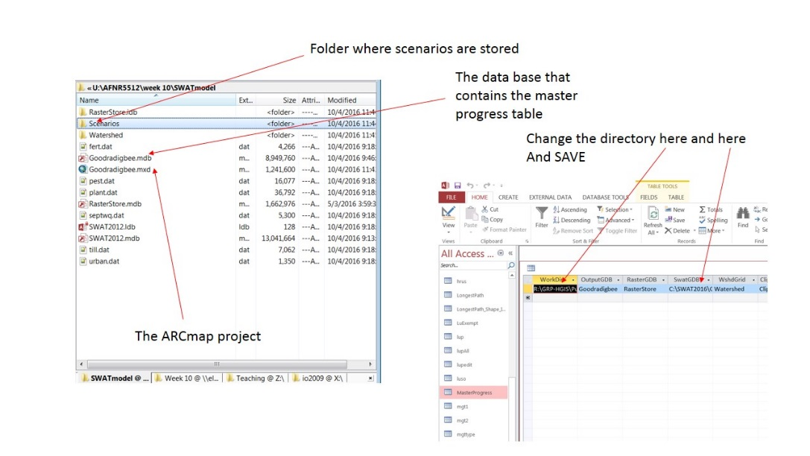

Figure 1 How to change the master progress table in the SWAT directories

# Capturing the best parameters from SWAT-CUP for the SWAT model

The first step is to capture the best simulation in SWAT-CUP and use this as out SWAT model for looking at landuse change. Our original model was uncalibrated, so that is not very useful, we want to make sure that the model at least captures the actual streamflow in some way.

You might want to think about how the “fit” or “lack of fit” in the calibration will affect your future scenario runs.

## Finding the best simulation

**SUFI2**

1. If you did SUFI2 Open SWAT-CUP and find in your final calibration iteration “Summary_Stats.txt” and open this.

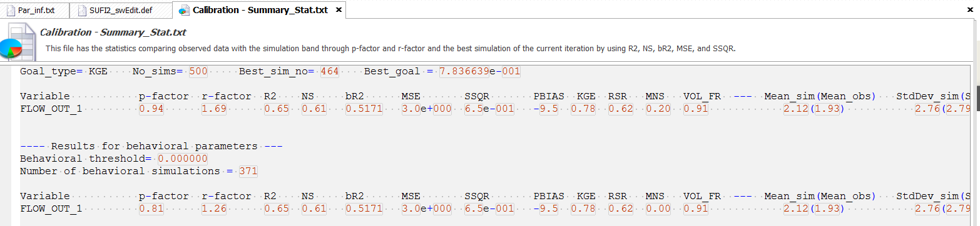

In this file you can see what the Best_sim_no is. In my case this is 464.

1. Now open from your **Calibration inputs** **at the top** (so not in the last iteration) the SUFI2_swEdit.txt and par_inf.txt file. In the SUFI_swEdit.txt file put in the Best_sim_no twice:

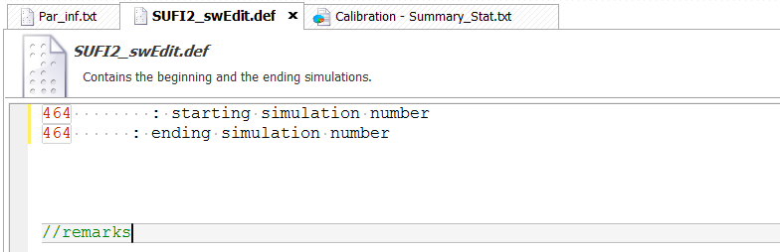

While in par_inf.txt indicate that you only want to run 1 simulation:

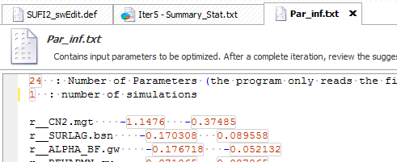

1. Run Calibration and it should stop after one model run

**PSO**

PSO is slightly trickier, but still fairly easy.

1. In your last and best calibration iteration, open up the best_par.txt file and copy all the parameters (so only the parameters):

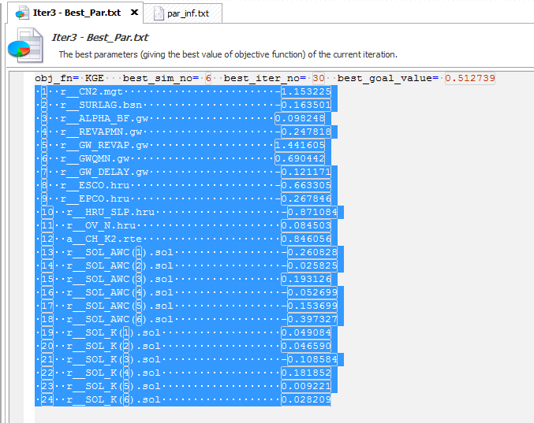

1. Now open up the par_inf.txt and paste the parameters in, but delete the consecutive numbers in front of the parameters, and set the number of simulations and iterations both to 1:

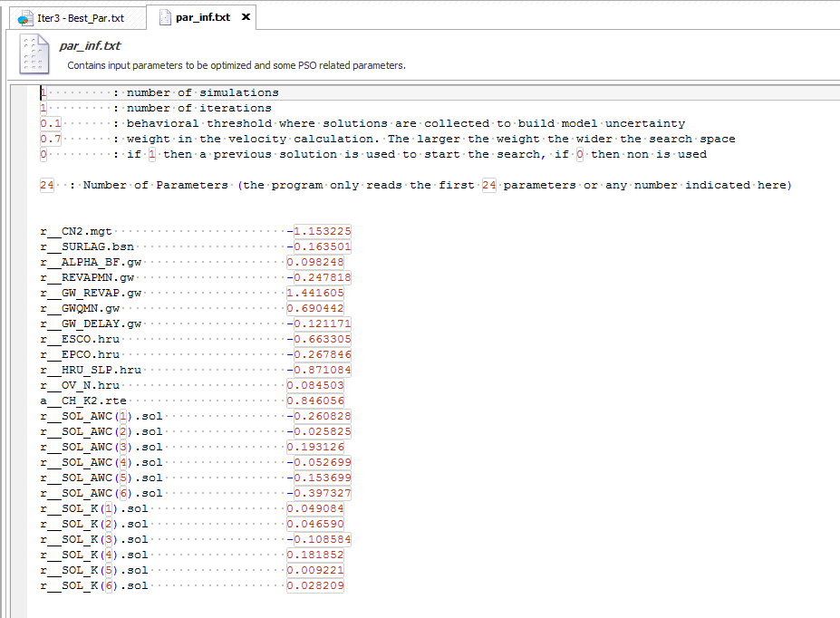

1. Run the calibration again, but in this case is should only run the model once.

## Copying the files back to the SWAT model

At this point the SWAT input files in SWAT-CUP are the best simulation, so we now want to copy these back to our original SWAT model. In my case I first made a copy of the original model, to my Landuse simulations and called this CotterLU:

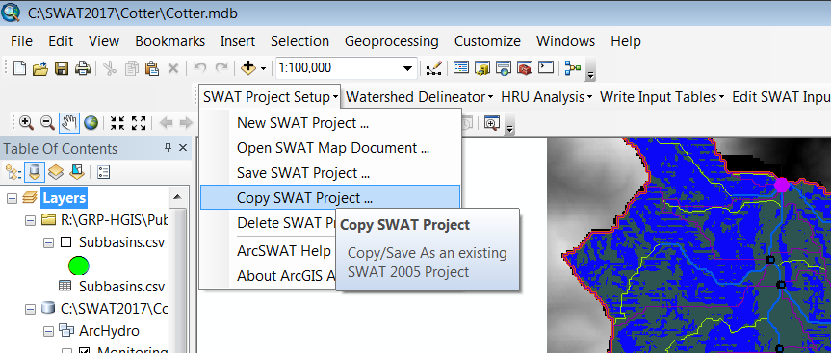

Once this was done, I navigated to the txtinout folder for this new model:

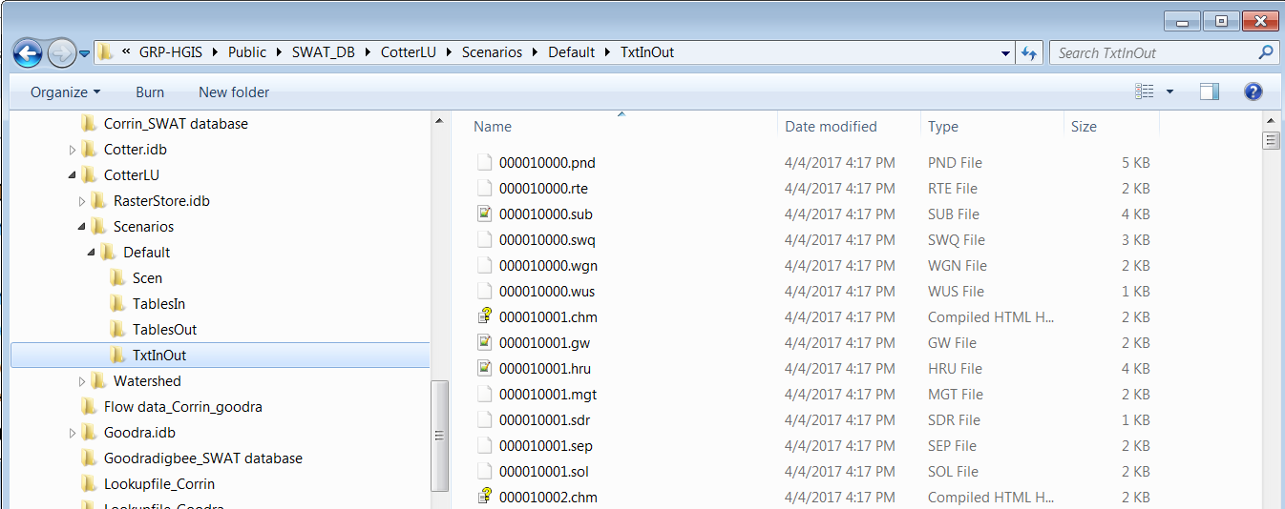

And to the Cotter SWAT-CUP folder and selected all the files not worrying about also selecting the specific SWAT-CUP files:

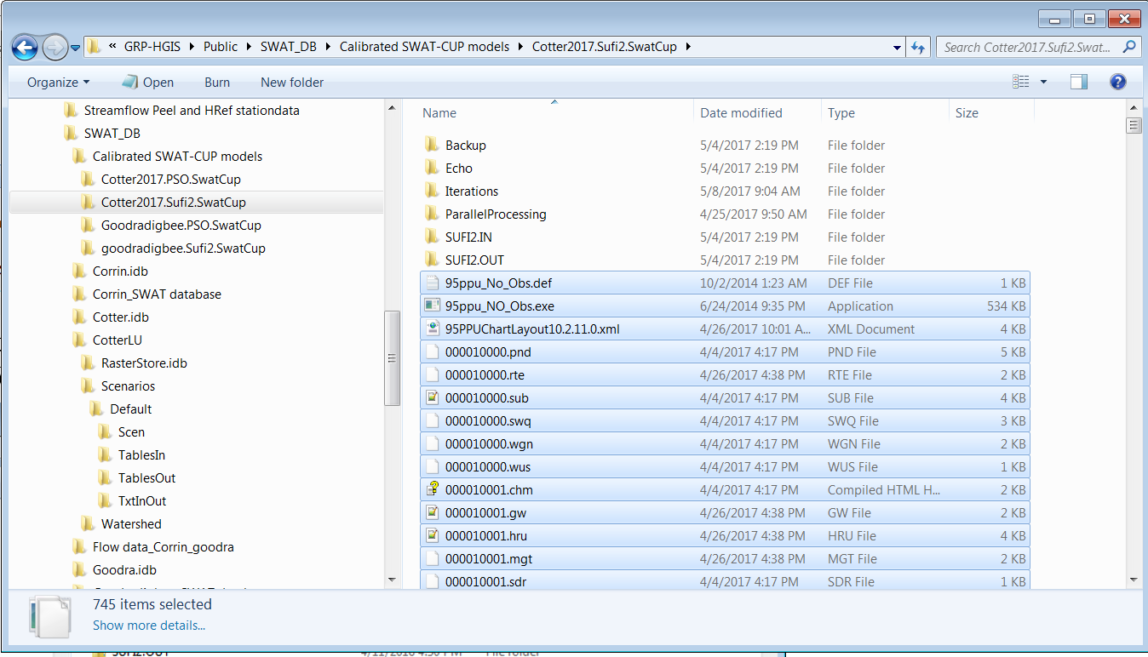

And subsequently copied all the SWAT-CUP files into the CotterLU/scenarions/default/txtinout folder. Now the CotterLU model is the calibrated model and we can use this to run landuse scenarios.

## Running the base scenario

To start off, just run the model for all 12 years as a base scenario:

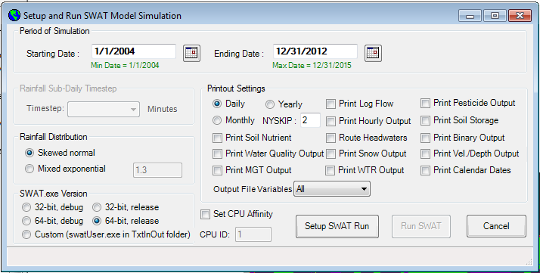

Then use the “read SWAT output” menu item to save this as a base simulation:

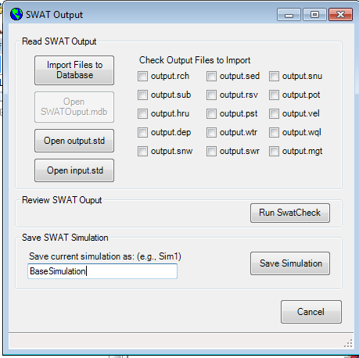

# Approach 1, using the .ops file

The first approach we will tackle is to use the .ops file which allows the specification of certain management operations and studying the effect on the outflow. The limitation in the .ops file is that the number of operations that can be changed in the interface is fairly limited. Luckily one of the options is a fire, but the fire operation in SWAT is more focussed on stubble burning than on a real bushfire, so we have to tweak the simulation slightly to also allow regrowth.

## Fire

Open up the .ops file editing interface by editing SWAT subbasins input and choosing the .ops file. Just choose subbasin 1, landuse FRST etc.

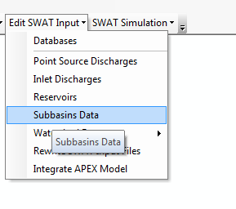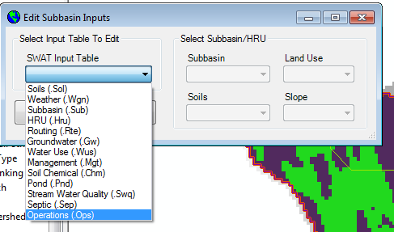

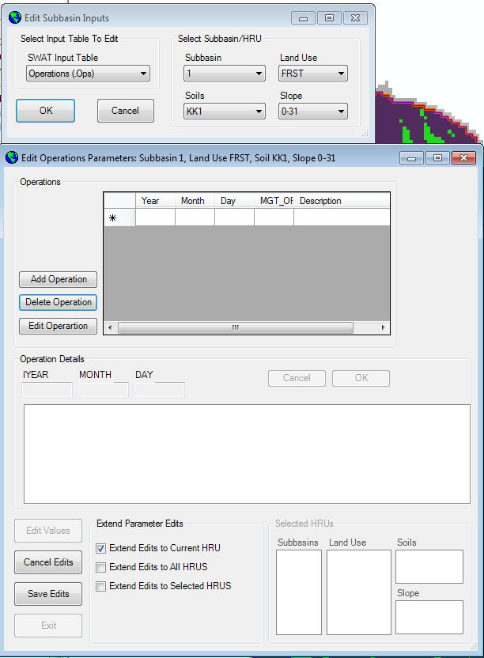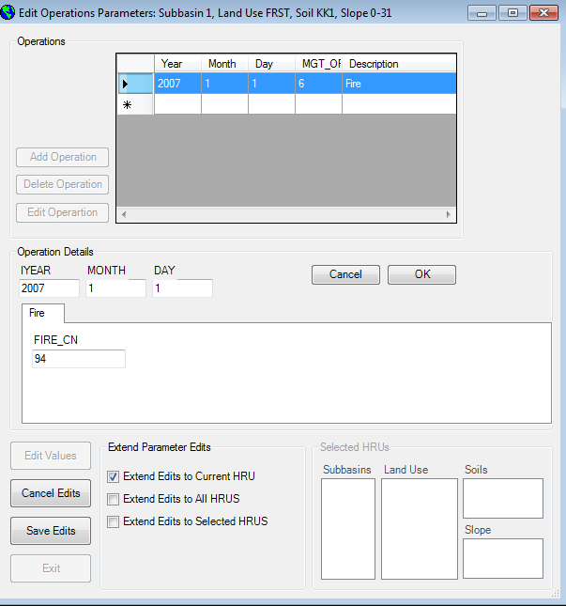

Choose “edit values” and “add operation” and choose “Fire”. This should allow you to edit the date of the fire and the curve number after the fire has gone through as you can see this is set to something quite high (94) as a suggestion. We will go with this number for now, but later will adjust to make it more realistic.

After you have done this extend the edits to the first 15 subbasins for all FRST HRUs and all soils and all slopes (or maybe we will vary this across the class to see some different effects). And save edits.

Next we need to rewrite the SWAT input files, and in particular the .ops files.

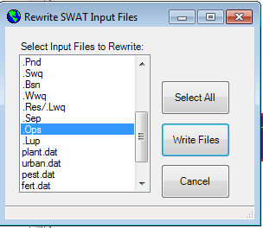

## Rerunning the model

Now we just have to rerun the model:



Then once again use the “read SWAT output” to save this as the “fire simulation scenario”

## Plotting

Use the R script demos from Monday to plot the difference between the base scenario and the fire scenario. There is also another demo script in the week 9 folder called “ExtractSWATresults.R”

As you can see from the results, the fire has a dramatic result on the runoff, mainly because of the change in curve number. If you think back to your SWAT-CUP sensitivity analysis results you can see that really curve number always has the most dramatic effect on the streamflow prediction results.

## Regrowth

There is no operation for regrowth, but we can put in a few operations to trick SWAT and make a regrowth scenario.

The main components of the regrowth scenario post fire would be (thinking of the Kuczera curve):

1. Increase in plant ET
2. Increase in the roughness (due to increase in live plants (understorey) and litter
3. A later decrease in plant ET moving towards maturity

To implement this in the .ops file, I suggest the following entries:

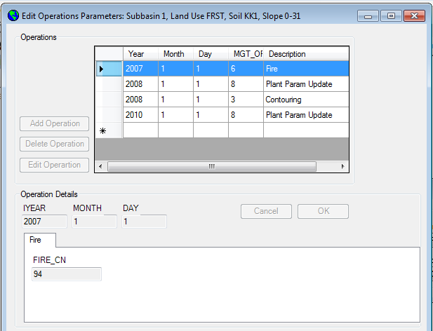

The first planned parameter update involves an increase in the maximum LAI to 7 (from 5) for crop number 6 on 1 January 2008 (one year after the fire). Note that you also have to set the Harvest Index update to 0.76 to keep this constant.

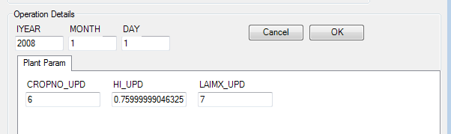

The next operation is a “contouring operation” this is a blunt instrument to create the reduction in the curve number, but there is no real other way to adjust the curve number, apart from putting in another fire.

I have set the new curve number to 60 (the original in my case seems to be 35, which is really low, but we can check for all models). I didn’t bother with changing contour P which relates to the USLE erosion prediction:

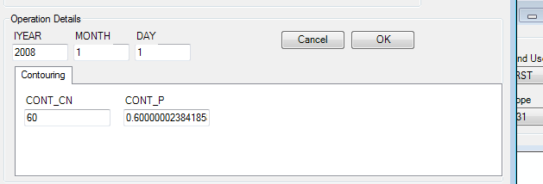

Finally, I put in another plant parameter update in 2010 to create the return to LAImax of 5:

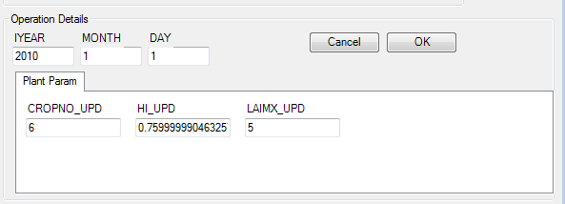

Extend the edits to the first 15 HRUs and save edits. Then update the Ops file by rewriting the input files and run the model again. Save the simulation using a different name

## Plotting

Use the R script demos from Monday to plot the difference between the base scenario, the fire scenario and the fire and regrowth scenarios.

## Class activity

Use the scenarios we have just developed to look at a range of different effects:

* Different post fire curve number. Check the curve number tables to find a curve number for an A hydrologic group and fallow and use this as a post fire curvenumber
* Different contouring curve number. Check tables and find a reasonable curve number to work for the forest while regrowing, taking into account the original curve number
* Test another maximum LAI for the regrowth, does this have an effect?
* You could implement smaller time steps in the operations for the regrowth, put in more contouring operations, but change the curve number.

Use R to look at the change in the downstream flow, but also in one higher order subbasin of the first 15 sub basins. You can look at ARCSWAT to see if you can locate a sub basin that is furthest upstream.

# Approach 2 using the .lup file

This approach can only be used if you have multiple landuses within one subbasin. So the Landuse update can only shift a percentage landuse from one landuse to another landuse. This means we cannot use the Cotter model as this only has one landuse (FRST), but we can use the Goodradigbee model and clear some more land for agriculture, or plant some more trees.

The first step is to once again make a copy of the Goodradigbee SWAT model in ARCGIS and to copy the files from your Goodradigbee calibration. If you worry about your version, I have loaded a calibrated version with PSO on the GRASP drive.

Changing landuse using LUP.dat

This is using the menu item under watershed data and under Edit SWAT input.

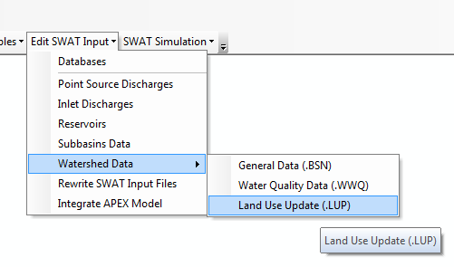

Which opens up the following interface and we are going to “Add Land Use Update” and this is going to again happen from the 1st of January 2008.

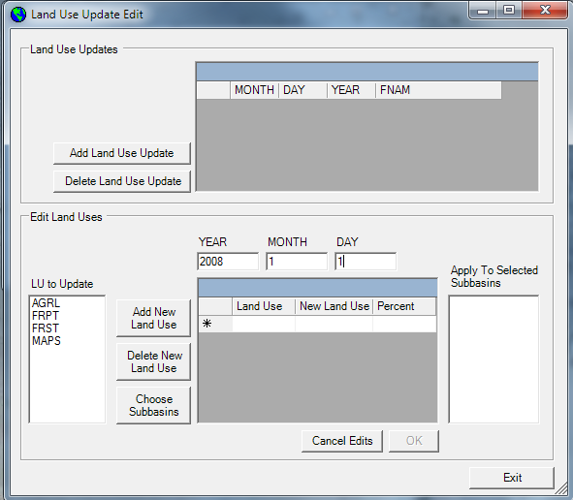

We are going to change all the FRST landuse to cropping, so doing some rigourous land clearing. This is not necessarily realistic, but it serves the purpose of the demonstration. So choose FRST in the LU to Update and the click Add New Land Use and choose AGRL. This immediately suggests to change 100% of the landuse. Clicking on the “Choose Subbasins” button brings up a list of subbasins where you can actually apply this (i.e. subbasins which have both FRST and AGRL). Select all the subbasins and click OK.

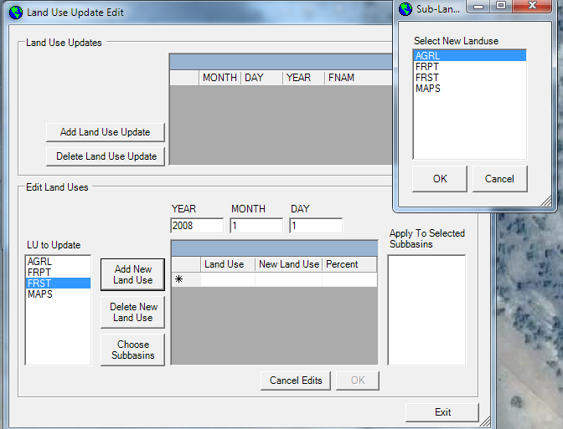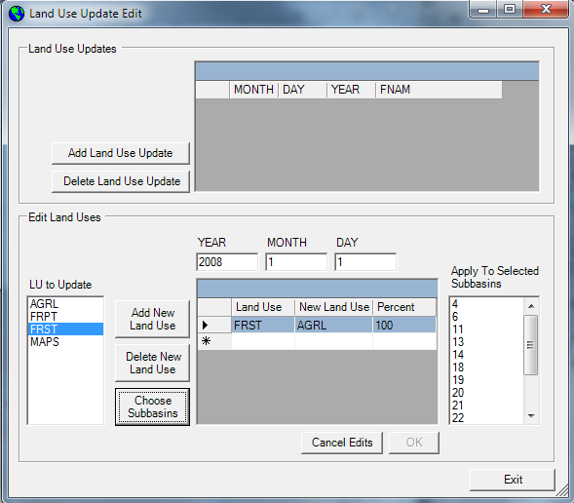

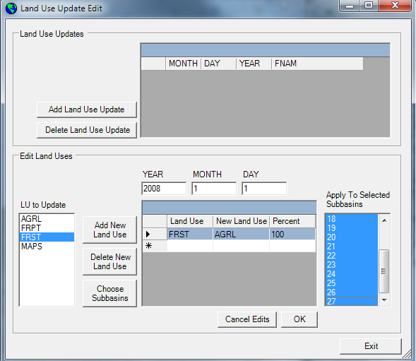

Once this is done we will need to update the SWAT input files, which we again do by using “rewrite SWAT input files”. Select the .Lup files and “write Files”.

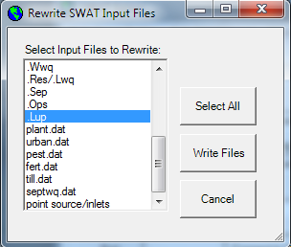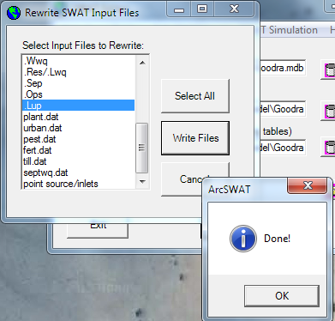

Now rerun the model and save the simulation as SimulationLandclearing

Use the Rscripts to plot the changes in water yield, groundwater, surface water and soil moisture.

## Class activity

Perform the following landuse changes:

* The reverse from the above, plant all AGRL with trees using FRST
* Change FRST to MAPS and the reverse
* Change AGRL to MAPS and the reverse (extension of pasture or cropping)

## The dam (reservoir) management interface in SWAT

Via the “edit SWAT input” menu item you can access the reservoir input file. Once you click on “edit values” you can access the different elements. The description of each of the entries is in the input-output manual from SWAT, but this might still need some clarification:

<http://swat.tamu.edu/media/69386/ch29_input_res.pdf>

Here we are not going to worry about water quality, but, as you can see, you can deal with sediment via the “SED” and “D50” entries in the interface. Sediment in SWAT is coupled to nutrients, so you can do some interesting work around this.

Crucial in SWAT (as I found out, ☺) is to make sure you keep track of the units.

The reservoir I put into the model is a copy of “Cotter dam” which supplies water to Canberra (<https://en.wikipedia.org/wiki/Cotter_Dam> and yes, Wikipedia is good enough for this, but note that there is an error, the catchment area is 482 km2 and not 482 ha). I used the data for the Cotter reservoir to define the “emergency spill way area” (RES_ESA) and emergency spillway volume (RES_EVOL). The values for the principal spillway (RES_PSA and RES_PVOL) were made up and the starting volume (RES_VOL) is a guess as well and probably high, you can try starting at a lower volume (say 1000×104 m3).

IYRES is the year the reservoir came in operation. We can manipulate this to start at different dates, but in this case we want the reservoir to be there when the simulation starts.

In the Reservoir management section you can specify different elements of the reservoir management. The first component is that I am using the simulated target release, which basically tries to mimic a typical “unmanaged reservoir” that overflows. What happens is that the system will overflow if it is above the “principal spillway” to bring it back to this point. How fast it overflows depends on the size of the spillway (RES_RR) and on the NDTARGR parameter. If the last is a large value than water is only released slowly, while a small value means that water is released quickly. This depends on your view of how floods will be managed. This will be the main parameter you can play with. I have set it to 10. In other words, if the dam is above the principal spillway, the overflow will use 10 days to bring the volume back to that level.

If you go to the “Monthly data” tab then you can access different input fields to define what happens on a month to month basis. I have put in data for two things:

* Minimum monthly flow, to mimic some sort of environmental flow (we will get to this)
* Consumptive use, to mimic some kind of multipurpose dam that manages both floods and water supply. The consumptive supply was based on the water use targets from “Icon Water”, which is the water supply company for Canberra. Their website : <https://www.iconwater.com.au/My-Home/Saving-Water/When-can-I-water/Water-use-targets.aspx> suggest full supply water use targets between 250 – 350 L per person. So scaling that to 100,000 people is 2.5 – 3.5 × 104 m3 of consumptive water use per day, which is what the SWAT interface wants. Using a ballpark for 300,000 inhabitants and 3 × 104 m3 as the median, I put 9 in all monthly entries.

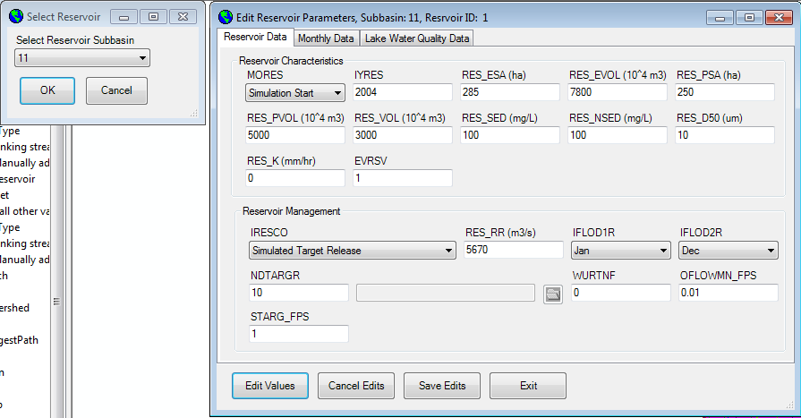

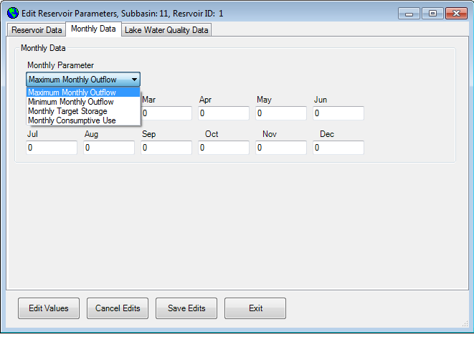

Figure 2 The reservoir file interface with reservoir characteristics and monthly data

## Running the base scenario

To start, we want to run the model without a reservoir. This is easy, we simply set IYRES in the interface to 2016 (after the model data ends). The rewrite the .res and .lwq files and run the model.

Then use the “read SWAT output” menu item to save this as a no_dam or no_reservoir or base simulation:



# Scenario 1 Minimum environmental flow targets (base scenario with reservoir)

For this scenario, the first thing to do is to change IYRES back to 2004. The second part involves determining what the minimum environmental flow would be. A typical benchmark for environmental flows is the so-called Q80, or the flow that occurs 80% of the time in the catchment. In this case we want to maintain the Q80 in the catchment, so this will determine our monthly minimum flow requirement.

## Determine the Q80 for the no dam scenario in SWAT

First load some libraries.

require(data.table,quiet=T)  
require(dplyr,quiet=T)

##   
## Attaching package: 'dplyr'

## The following objects are masked from 'package:data.table':  
##   
## between, last

## The following objects are masked from 'package:stats':  
##   
## filter, lag

## The following objects are masked from 'package:base':  
##   
## intersect, setdiff, setequal, union

require(zoo,quiet=T)

## Warning: package 'zoo' was built under R version 3.3.1

##   
## Attaching package: 'zoo'

## The following objects are masked from 'package:base':  
##   
## as.Date, as.Date.numeric

Then load the utility functions that we have used last week in the practical to read in the data.

setwd("U:/My-workspace/rver4657/LWSC3007")  
# load the utility functions  
# you can modify the utility functions if you would like to extract other components  
source("Extract_subbasin.R")  
source("RCH_extract.R")

Now we can read the default input and extract the sub catchment of interest. The one we want (and you can check this on the SWAT GIS version) is subcatchment/reach (rch) 6.

basewd <- "C:\\Users\\rver4657\\Documents"  
# output.rch file gives the flow in column 7 (See SWATCUP input files)  
SWAT_Out <-   
 RCH_extract(wd =paste(basewd,"Cotter_dam\\Scenarios\\Nodam\\TxtInOut",sep="/"),  
 rch = 6, d.ini = "2005-01-01", d.end= "2015-12-31")  
  
plot(SWAT_Out)

From this data we can extract the Q80 using the quantile() function, but remembering that this goes from high to low in R, so we actually want the probability to be 0.2.

Q80 = quantile(SWAT_Out,0.2)  
Q80

## 20%   
## 0.57768

So this suggests it is 0.57768 cumecs (), which we need to convert to , because even though the interface says: "minimum monthly outflow", the [manual](http://swat.tamu.edu/media/69386/ch29_input_res.pdf) actually tells you: Minimum daily outflow for the month (). In other words 6.686111e-06, which is essentially nothing. We will put in a value of 0.001 for now.

Then use the “read SWAT output” menu item again to save this as the “dam” or “reservoir” simulation.